|  |
| --- |
| **CLOUD-NATIVE**  **NETWORKING FOR**  **A 5G ERA** |
| Don Alusha  *Senior Analyst* |



TABLE OF CONTENTS

1. 5G AND CLOUD-NATIVE

NETWORKING MARKET OVERVIEW ....2

1. CLOUD-NATIVE COMPUTING:

A WEBSCALE VIEW .............................3

* 1. Lessons Learned ........................3
  2. Cloud-Native Value

Proposition ................................4

* 1. Need for Network

Disaggregation ..........................5

1. 5G NETWORK ARCHITECTURE

EVOLUTION .......................................6

* 1. Evolving from Virtual Network

Functions to Cloud-Native

Functions ...................................6

* 1. A 5G-Ready Network Cloud .......7
  2. The Need for Disaggregation in the 5G Era ..............................7

1. ORCHESTRATION AND SERVICE

LIFECYCLE MANAGEMENT .................9

* 1. Service, Network, and

Resource Orchestration ..............9

* 1. E2E Orchestration from

5G Core to Edge Cloud

and Public Cloud .....................10

* 1. The Rise of an Application- Aware Network ........................10

1. DRIVENETS NETWORK CLOUD .........12
   1. Overview of DriveNets

Network Cloud ........................12

1. CONCLUDING

RECOMMENDATIONS ......................13

1. 5G AND CLOUD-NATIVE NETWORKING

# MARKET OVERVIEW

Communications Service Providers (CSPs) are seeking to transform their network infrastructure, automate operational processes, and transform internal mindsets to capture new growth. The transformation is being driven, in part, by a growth of user data demand, a massive increase in connected devices, an overly complex network, and new Business-to-Business (B2B) revenue growth increasingly tied to 5G adoption. A question of significance for telcos is how to embed a degree of agility in networks and scale up the emerging enterprise use cases in a way that is sufficiently impactful and not disruptive. This is particularly important for new 5G-centric use cases (e.g., network slicing and 5G private networks) that will almost certainly consist of network elements and services that traverse different technology domains.

CSPs are asking three questions before they adopt a new solution based on cloud-native computing principles: 1) does it help change existing processes; 2) does it change workflows; and 3) does the solution (and the vendor providing it) help them acquire the necessary human capital that will be key for an internal “change” toward global software-centric networks. Such changes will almost certainly be propelled by CSPs’ ability to achieve the right mix of telcos, agile DevOps methodologies, big data and analytics expertise in shaping new services. A nimble way of transacting business will be a key aspect for the industry’s push into alternative enterprise revenue streams. This constitutes a horizontal play among CSPs, solution providers, and end verticals to create new value based on use cases that leverage high-capacity and scalable networks. For example, cloud gaming is a significant revenue opportunity for the industry that necessitates guaranteed latency and high bandwidth capacity that can be scaled up/down on demand.

Telcos are on the cusp of a new horizontal chain of command for value creation. But for that value to be fully unlocked, there is a steep learning curve to conquer for both vendors and CSPs. For vendors, the impending “flattened” landscape constitutes an opportunity to redirect investment and energy toward creating cloud-native products that are easy to consume. For CSPs, software-centric networks are going to be at the center of new commercial forays, particularly enterprise 5G, which inherently constitutes a horizontal value creation. CSPs will capture growth if they get three strands right: the intelligent connectivity to connect with cloud-native 5G platforms; the education to get their workforce innovating on, working off of, and tapping into the impending telco intelligent ecosystem; and finally, the governance to get the best out of this ecosystem and cushion its side effects.

2. CLOUD-NATIVE COMPUTING:

# A WEBSCALE VIEW

## 2.1. Lessons Learned

Cloud-native tooling enables CSPs to embed agility and scalability in their network operations, processes, and data center deployments. In general, cloud-native products enable the consolidation of much more functionality in less hardware. There is, by now, widespread agreement that cloudnative computing is bound to be a key enabler for a more “digital” telco ecosystem. In the webscale domain, cloud-native principles lay the groundwork for myriad use cases predicated on Infrastructure-as-a-Service (IaaS), Platform-as-a-Service (PaaS), and Software-as-a-Service ((SaaS); e.g., hosted apps) deployment environments. The eventual evolution from physical and proprietary equipment to malleable and scalable software-based network platforms (e.g., white boxes and Software-Defined Networking (SDN)) will be anchored on three pillars:

1. **Infrastructure Immutability:** Immutability implies that networking is loosely coupled with the underlying infrastructure, holding no unique properties and, therefore, easily replaceable. If one instance falls over, another can take its place and quickly generate further replacements.
2. **Ecosystem Openness:** The notion of openness is best summarized by the End-to-End (E2E) principle—the ability to send an Internet Protocol (IP) packet from one host to another host, each located somewhere at the edge of the network, without the need to (re)configure proprietary protocols and solutions to achieve interoperability, a common occurrence in telcos.
3. **A Declarative DevOps Approach:** Cloud-native networking leverages a declarative (modellike) DevOps approach that is more suitable for agility and scale than the “old” imperative (scriptlike) model. This bodes well for life cycle management of multiple functions in a network service chain as a single service-level entity through which traffic will pass. Figure 1: Key Lessons for Cloud-Native Computing

***Servers, virtual machines***

***VMs), containers***

***(***

Core Building Blocks

***Heavy, protocol***

***-***

***based***

***equipment to light weight in***

***spin up time and size***

Isolation Units

***From pets to cattle***

***–***

***easy***

***disposability of***

***infrastructure***

Immutability

***From closed source and***

***single vendor to open source,***

***cross***

***-***

***domain, cross***

***-***

***vendor***

Ecosystem Openness

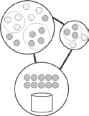

***Lessons Learned from Webscale Players***

*(Source: ABI Research)*

## 2.2. Cloud-Native Value Proposition

CSPs believe that they will reap the full benefits of software-centric networks when the entire network architecture is built in a cloud-native way. E2E network cloudification is particularly important and remains the foundation to successfully unlock the commercial potential of network slicing, Ultra-Reliable Low-Latency Communications (URLLC), and a 5G standalone core network. Leading CSPs are investing in and, in some cases, mandating cloud-native methodologies and DevOps patterns of software development. The value proposition for cloud-native methodologies lies in scalability, complete resilience across hybrid (virtual and physical) architectures, and ultra-rapid deployment and innovation cycles for new features, applications, and services. Specifically, there are five broad benefits that come from cloud-native computing:

1. **Enables Scalability:** Cloud-native operations scale to tens of thousands of self-healing multitenant nodes, while retaining the ability to function when the load increases.
2. **Increased Agility and Maintainability:** A loosely coupled, lightweight virtualization approach (e.g., containers) gives CSPs the agility to quickly create new products and services.
3. **Realizes Resiliency:** CSPs are seeking systems that are able to adapt to changing conditions in the network. Cloud-native methodologies provide functionality in robustness and availability.
4. **Improved Efficiency and Resource Utilization:** CSPs can benefit from the efficiency of resources because, unlike Virtual Machines (VMs), there is no framework with dedicated physical memory and dedicated physical Central Processing Unit (CPU) cores.

**• Avoids Vendor Lock-In:** Cloud-native computing promotes ecosystem openness, which, in turn, enables cross-vendor, cross-domain deployments on any public, private, and hybrid cloud.

## 2.3. Need for Network Disaggregation

A key consideration for the industry is how to shift Network Functions (NFs) from physical instances to containerized microservices and disaggregated business models. This poses new requirements for the coordination, orchestration, and control of highly disaggregated and distributed capabilities. 5G’s role to shift telco network functions into disaggregated and modular architectures is further emphasized by The 3rd Generation Partnership Project’s (3GPP) Release 15. Unlike previous specifications where interfaces between network functions are represented by box-specific “reference points,” the notion of “service-based interfaces” is introduced to denote interaction between network functions.

Clearly, this is an architectural refinement more conducive to cloud-native networking, and potentially another indication of a future in which mobile networking is highly modular and disaggregated. The true value of such a disruptive model is not necessarily limited to up-front cost-savings as indicated in Figure 2. Rather, the value lies in the optionality that comes from building an infinitely scalable and malleable network cloud platform that is pay-as-you-go. This stands in contrast to massive capital investment that, if new commercial use cases do not take off, quickly becomes a financial burden.

## Figure 2: Disruption of Network Equipment Market

**Time**

**Growth**

**Underserved**

•

Optimum

performance

•

Interdependent (proprietary) architecture

•

Feature differentiation and pay

-

up

-

front

model

•

Relatively low volume, high price and

high

switching costs

**Well served**

•

Modular architecture

•

Convenience and flexibility

•

Price differentiation and lower

prices

•

High volume and pay

-

as

-

you

-

go model

**Cloud Native**

**Platforms**

**NFV/CNF**

**SDN**

**Merchant**

**Silicon**

*(*

*Source: ABI Research*

*)*

# 3. 5G NETWORK ARCHITECTURE EVOLUTION

## 3.1. Evolving from Virtual Network Functions to Cloud-Native Functions

CSPs are in full swing in terms of shifting their NFs to software appliances. In practice, there are three options to implementing an NF. An NF can be implemented as an element on a dedicated hardware, as a software instance running on hardware (a Virtual Network Function (VNF)), or as a virtualized/Cloud-Native Function (CNF) running on cloud infrastructure. NFs based on specialized and proprietary equipment are typically associated with back doors that can potentially lead to (invisible) dependencies between apps and workflows. That does not bode well for a modular, disaggregated architecture where speed and convenience drive competitive success.

VNFs, on the other hand, take a single-service, single-tenant focus that does not offer a clear path to a scalable, unified software-driven network cloud that can ultimately serve as the foundation for new commercially viable applications. For network workloads that need to scale dynamically and on-demand, CNFs are more suitable. The NF of the future may well be a combination of all three network function types, and the exact network variation will vary with CSPs’ progress and position in their digitalization journey. But CSPs must chart a commercial course that aims for scale. They should think broadly from the start to create a network that affords capacity, nimbleness, and new revenue streams and cloud-native elements will most certainly be a key enabler of that vision.

## Figure 3: Evolving from VNFs to CNFs

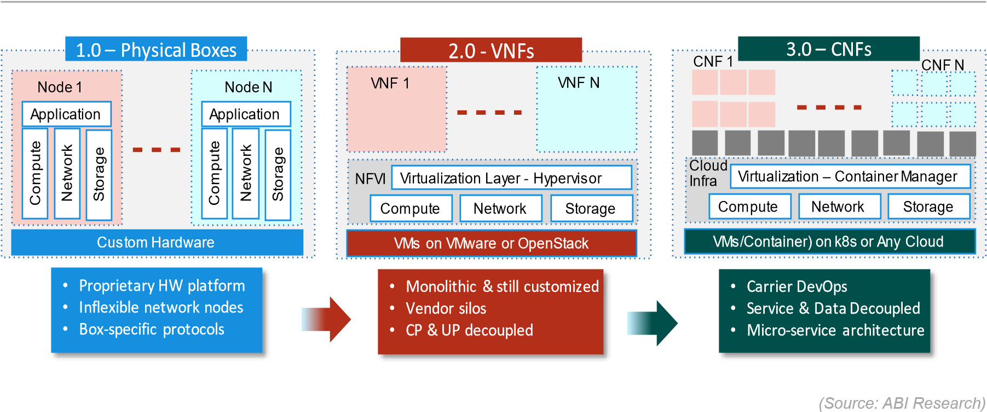

## 3.2. A 5G-Ready Network Cloud

The bulk of commercial engagements for telcos revolve around consumers and generic, connectivity-driven use cases. The industry is driven by standards and remains anchored to an engineering-centric approach and network assets that underpin its position in the global production frontier. With the advent of 5G, an agile delivery mode that piggybacks on a hyperscale-like network cloud to deliver customized and even personalized (consumer and enterprise) use cases is bound to take center stage. This is particularly significant for an industry that is firing on all cylinders to 1) streamline CSPs’ operations, 2) pursue new revenue streams, and 3) compete as effectively as possible with webscale players.

But, for an industry anchored on physical and inflexible networks, immediate diffusion of a cloudnative networks will not come without challenges. Some telco processes and operations remain that are characterized by performance requirements still met by specialized and vertically integrated equipment. Functionality residing in base stations for radio (e.g., control plane signaling) and fixed-line access (e.g., optical line terminals and passive optical networks) require a very mature cloud-native network cloud. There is, therefore, a requirement for the industry to determine which telco applications are good candidates for a network cloud. Some examples include:

* **Control-plane network functions** (e.g., Session Management Function (SMF), Access and Mobility Management Function (AMF), Policy Control Function (PCF)) can be shifted into cloudnative equivalents.
* **User-plane network functions** (e.g., User Plane Function (UPF)) can be built using cloudnative functionalities, but on the condition that there are telco-grade enhancements.
* **Database-related network functions** (e.g., Unified Data Repository (UDR)) are stateful and, therefore, may not be immediately recommended for cloud-native functions, which are fleeting and light in nature.

## 3.3. The Need for Disaggregation in the 5G Era

At its foundation, the industry is geared toward “naturally vertical” mass-market, country-specific consumer services, where the commercial modus operandi revolves around Average Revenue per User (ARPU), bits, and units. Going forward, new and sustained commercial growth will come from E2E “naturally horizontal” platforms that interface with other programs where the value, in part, is providing a stable, standard interface. An inherently software-centric network, such as 5G, is almost certain to supplant the verticalized, siloed operations of today, but on the condition that there is wider ecosystem openness and disaggregation.

## Table 1: Selective Drivers for Disaggregation in 5G Networks

|  |  |
| --- | --- |
| Drivers for Disaggregation | Description |
| Dynamic and real-time network maintenance | Automated and closed-loop maintenance predicated on model and policy-driven processes, open Application Programming Interfaces  (APIs), and cross-domain and real-time data and telemetry. |
| Multi-vendor 5G network deployments | Multi-vendor, modular, and horizontal stack for 5G core deployments that are interoperable among multiple clouds (e.g., telco cloud, edge, public). |
| Cloud-native methodologies and technologies | Underpinning technologies include Kubernetes, microservices, state-optimized design, service mesh, network service mesh, PaaS, Machine Learning (ML)/Artificial Intelligence (AI). |
| Malleable software design | Software design is pegged to fine-grained, isolated, and elastic functions (microservices) based on declarative (model-like) DevOps and cloud principles. This is in contrast to physical appliance characterized by coarse-grained component granularity, linear processes, and prescriptive/imperative (script-like) model. |

*(Source: ABI Research)*

5G networks will be a starting point for new “horizontal” growth forays into enterprise verticals. Increasingly, the ability to think horizontally by connecting disparate and disaggregated tools using a common platform will be a priority for CSPs. Furthermore, there is widespread agreement in the industry that favors multi-vendor stacks for 5G networks as opposed to whole-stack integrations from a single vendor. Regardless of which deployment model prevails, in order to reap the full benefits of cloud-native features (see Table 1), full immersion of cloud-native technologies into a rigid telco framework must be avoided.

4. ORCHESTRATION AND SERVICE

# LIFECYCLE MANAGEMENT

## 4.1. Service, Network, and Resource Orchestration

Applications and services in cloud-native networks are assembled and compiled from a collection of microservices located in multiple domains, as opposed to being built. Consequently, next-generation services need to be orchestrated as applications that collect inputs from myriad diffused microservices. The challenge is further exacerbated when CSPs adopt cloud-native solutions that, in addition to mere technology functionality, also center on context and experience. There are not only network elements, there are relationships, too. It follows that E2E life cycle management predicated on multi-domain monitoring and automation capabilities is of paramount importance for prospective orchestration solutions suitable for dynamic cloud environments.

Network services represent the logical view of low-level physical network resources, formerly proprietary software systems, but increasingly characterized by openness and disaggregation. Atop these resources, technical workflows and digital business processes are being (re-)sequenced together as compositions of services. With the emergence of digital services and fluid network architectures, business utility will now result from how CSPs take the value at the network/resource layers and surface it to the top of the service layer to enable the creation of new apps, dashboards, and business processes.

## Figure 4: Abstraction and Automation Flows in Orchestration Solutions

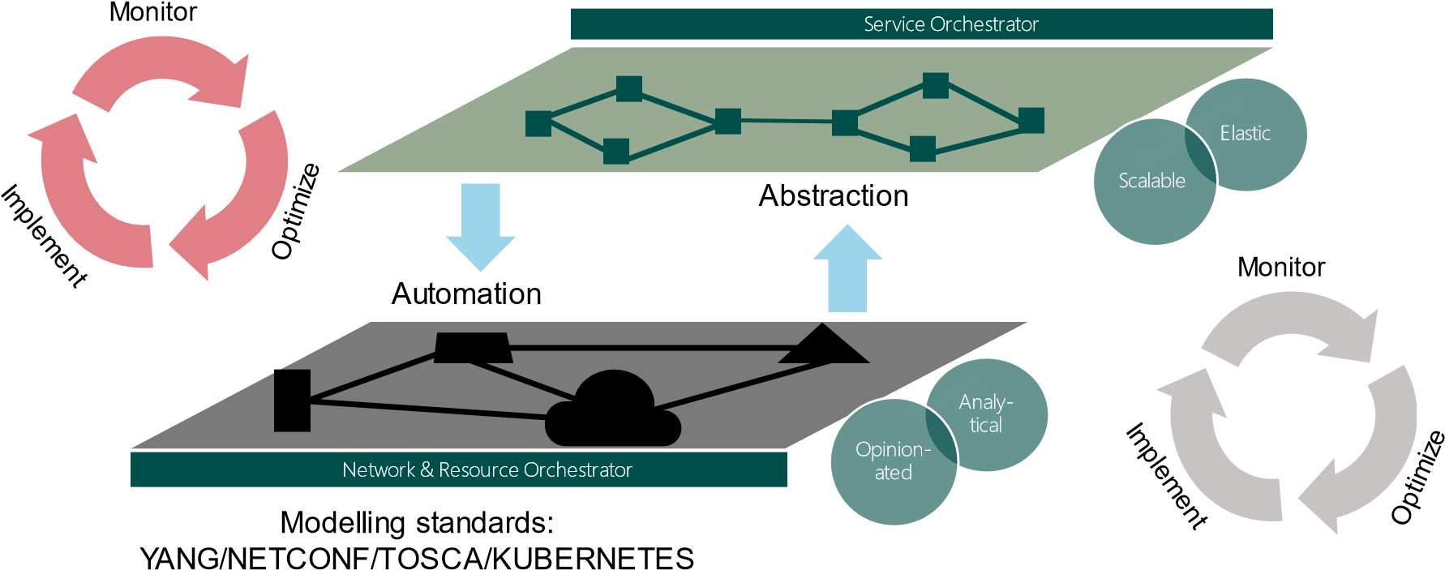

*(Source: ABI Research)*

The service layer, under the auspices of a service orchestrator, necessitates a dynamic mode of operation that automates high-level services into underlay network and computing resources and presents them to the network/resource orchestrator. A network orchestrator can autonomously tear up/tear down and scale resources in response to network changes either at the underlay or at the top layer(s). A viable resource-layer orchestration product must work seamlessly with the top service layer of both enterprise application delivery and telcos where its network services are being sold. But increasingly, there will be tailored enterprise and industrial engagements that will be monetized with 5G and edge compute.

## 4.2. E2E Orchestration from 5G Core to Edge Cloud and Public Cloud

A single-layer solution in isolation, whether it is at the resource or service layers, will not yield optimum results in 5G networks expected to go beyond consumer services by catering to multiple enterprise use cases. Increasingly, CSPs are recognizing the need for E2E multi-layered orchestration that can provide the agility to quickly compose assets into new products and services in reaction to market needs. Vendors should replace manual processes or scripting with DevOps and programmable network architectures, so that on-demand services requested by the business are readily available. Furthermore, programmable networks, underpinned by merchant silicon, SDN, and cloud-native solutions, introduce disaggregated network functions that necessitate control over two dimensions:

1. The orchestration and management of NFs, a virtualized version derived from PNFs
2. The management of the virtualization aspect of the network function

An initial requirement for E2E orchestration in 5G networks is full integration of hybrid physical/ virtual environments and network functions, with an eventual full migration to a cloud-native network cloud.

## 4.3. The Rise of an Application-Aware Network

An “application-aware network” is a term often associated with a “composable” enterprise, a company where open APIs, data analytics, mobile, and the cloud blend to provide efficiency and lower-cost processes. Similarly, an application-aware network in telcos marks a departure from the linear processes of old models like Service-Oriented Architecture (SOA) to promote an API-led approach where the workflows are more dynamic and diverse. The key pillar of an application-aware network is reuse, or infrastructure immutability propelled by a disaggregated network cloud and CNFs.

## Figure 5: The Evolving Nature of Orchestration

**Network 1.0**

**Network 2.0**

**Network 3.0**

▪

Separate physical boxes for each

component (e.g., routers,

switches, firewalls)

▪

Top

-

down siloed orchestration



Opinionated and customer

-

led networks

▪

Physical boxes converted to

virtual network functions (VNFs)

running on open source

OpenStack) or proprietary VIMs

(

▪

End to end horizontal

orchestration

▪

CNFs running on cloud

-

native

network clouds for hybrid cloud,

multi

-

cloud, carrier

-

cloud, edge and

core

▪

Multi

-

layered, consumer

-

led,

vertical and horizontal

orchestration

▪

Application

-

aware networks



Box/system

–

specific orchestration

Vertical resource/service layer orchestration

*(*

*Source: ABI Research*

*)*

An application-aware network should be underpinned by a building block that encapsulates three distinct components: 1) open APIs on open market hardware; 2) intelligent connectivity; and 3) multi-layered, multi-domain vertical and horizontal orchestration (see Figure 5). When considering the genesis of these three strands, it is important to list the design principles that are expected to empower CSPs to surface the value provided by connectivity to the front of the business.

They are as follows:

* **Build an Opinionated Network:** Point-to-point connectivity is not conducive to agility and new revenue streams. Vendors should establish API-led and built-in opinionated ways that tend to the dynamic life cycle of network nodes.
* **Connect Applications to the Network:** At present, telco applications are mostly not connected directly to each other. There is, therefore, a need to implement service-layer abstractions that use rich meta-data coming from the network and expose that to the business layer.
* **Design Accessible, Elastic, and Modular Components:** The rise of disaggregated business models calls for network architectures that can flexibly meet changing requirements. These elastic solutions can grow or shrink with demand, but they raise a need for orchestration solutions that tailor their monitoring scope depending on application footprint.

# 5. DRIVENETS NETWORK CLOUD

## 5.1. Overview of DriveNets Network Cloud

DriveNets Network Cloud is a distributed disaggregated carrier-class networking solution predicated on cloud-native software principles and standard white-box functionality. The open-model networking that DriveNets advocates is anchored on the DriveNets Network Operating System (DNOS), a virtualization layer that sits atop white boxes and/or x86 servers for large cluster implementations, and that supports multiple services mainly for core, aggregation/peering, and edge routing. DNOS is built for any scale, enabling CSPs to implement the same routing functionality running on a standalone box. This can scale out as a single network entity in line with CSPs’ bandwidth needs. DNOS is predicated on the following cloud-native software design guidelines:

* **Natively Distributed Network Operating System (NOS):** DNOS marks a departure from the monolithic network hardware designed around a proprietary model of equipment. DNOS separates logical routing functionality from the physical infrastructure.
* **Extensive Use of Containers:** DNOS is designed from the onset to leverage Docker containers to ease development, deployment, and upgrade. The same software components and processes apply, regardless of the deployment architecture and topology.
* **Optimized Resource Utilization:** DNOS is anchored on small, highly cohesive, and looselycoupled microservices. For example, the management plane, control plane, and data plane are designed with a flexible framework that leverages the efficiencies of the resources available.

## Figure 6: DriveNets Network Cloud Disaggregated Solution

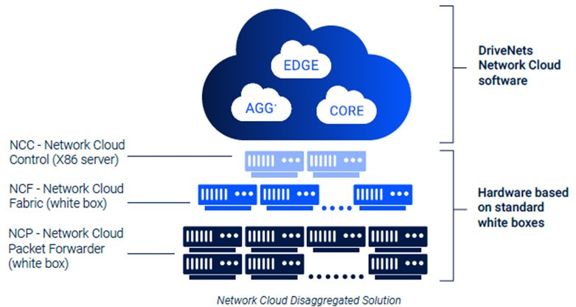

*(*

*Source: DriveNets*

*)*

On the commercial front, DriveNets’ solution points to open-model networking that promotes consumption economics. DriveNets’ software offering is available on a fixed-license basis, regardless of the CSP’s operational scale, while white boxes are sold on a cost+ model. This is an example of the industry’s increasing shift from the “old” pay-up-front Capital Expenditure (CAPEX) model to the pay-as-you-go Operational Expenditure (OPEX) model. This mirrors hyperscale cloud economics and, in theory, enables operational simplicity and infrastructure costs that can be controlled, giving CSPs a better grip on the business case.

# 6. CONCLUDING RECOMMENDATIONS

ABI Research’s recommendations for CSPs include the following:

**CSPs must work with both equipment vendors and disrupter companies to accelerate cloudnative computing adoption.** Some CSPs are opting for greenfield white-box deployments with the idea of subsequently rolling it out across the wider footprint. This is typically the case for CSPs who lack “legacy” deployments or for those who have resources in place to trial new technology alongside existing operations. Other CSPs, who represent the bulk of the market, need to take the initiative in looking for leverage points—places in the “old” networking operations where a small change can lead to a large shift in behavior. Irrespective of CSP readiness and the size of the investment pool, the MSP community should continue to leverage existing expertise from large equipment vendors, but also introduce “added value” from disruptor vendors for more flexible and “cloud-friendly” networks.

**Seek orchestration solutions and disaggregated network architectures that are conducive to an API-led connectivity approach.** To better foster a service-centric 5G ecosystem, CSPs should opt for disaggregated network solutions that focus on three strands: 1) break down business logic into granular resources; 2) establish process connections within and between discrete resource-layer components; and 3) expose new apps, business processes, and service-layer interfaces atop existing (legacy) network systems and data sources to enable the creation of new services that will almost certainly have higher bandwidth requirements. For example, cloud gaming provides new revenue opportunities, but on the condition that CSPs’ networks support higher bandwidth capacity accompanied by scalable network deployment options.

**Choose network cloud platforms that provide supreme visibility.** Network visibility may become a challenge due to the complexity of managing virtualized networks relative to physical ones. This complexity can occur in back doors that can give rise to (invisible) dependencies between apps and workflows. These dependencies may not bode well for a modular architecture where speed and convenience drive competitive success. CSPs must seek out solutions that provide full E2E visibility spanning a multi-silo, multi-domain hybrid infrastructure across edge and access networks, core, and aggregation/peering.

**Choose proven network cloud platforms that support high capacity and efficient scale.** Dataheavy applications (e.g., gaming, Virtual Reality (VR)/Augmented Reality (AR) and, increasingly, 8K) now constitute approximately 70% of the traffic. Furthermore, with 42 million cloud gaming users estimated by 2024, traffic flowing through 5G and fixed networks is expected to increase exponentially. Carrierclass networking solutions that are built for any scale and can be provisioned on-demand to handle network bursts (like COVID-19) are expected to serve as the foundational pillar for CSPs to pursue new commercial forays and achieving operational efficiencies.

**CSPs must use cloud-native solutions as a trigger to initiate an internal organizational transformation.** The technology plays a significant role in driving new growth for CSPs, but a cultural and process change may mark a real watershed in their quest to become more digitally-oriented entities. Innovation on the technology front has a causal effect on CSPs’ competitive global positioning, but it should be accompanied by internal cultural re-structuring that benefits from the utility on offer. A different mindset must be embraced and it must be driven from CSPs’ leadership. On the other hand, vendors will have a significant role to play in guiding CSPs to embrace new ways of working and highlighting the benefits of the broader cloud-native networking story.

## **Published March 31, 2020**

249 South Street

Oyster Bay, New York 11771 USA

**Tel: +1 516-624-2500** www.abiresearch.com

**www.abiresearch.com**



**© 2020 ABI Research • abiresearch.com •** Used by permission. ABI Research is an independent producer of market analysis and insight and this ABI Research product is the result of objective research by ABI Research staff at the time of data collection. The opinions of ABI Research or its analysts on any subject are continually revised based on the most current data available. The information contained herein has been obtained from sources believed to be reliable. ABI Research disclaims all warranties, express or implied, with respect to this research, including any warranties of merchantability or fitness for a particular purpose.

Intel disclaims all express and implied warranties, including without limitation, the implied warranties of merchantability, fitness for a particular purpose, and non-infringement, as well as any warranty arising from course of performance, course of dealing, or usage in trade. This document contains information on products, services and/or processes in development. All information provided here is subject to change without notice. Contact your Intel representative to obtain the latest forecast, schedule, specifications and roadmaps. Intel and the Intel logo are trademarks of Intel Corporation in the U.S. and/or other countries. **©** Intel Corporation.